Day 18 - 16th july 2025

Pending:

Heap Sort
Radix sort

Task01

What kind of collision resolution strategy is implemented in the below Hash Table ?
import java.util.*;

class Task01 {

LinkedList<Entry>[] data = new LinkedList[10];

public void put(String keyval, int value) {
int index = Math.abs(keyval.hashCode() % data.length);

if (data[index] == null) {
data[index] = new LinkedList<>();
}
for (Entry e : data[index]) {
if (e.keyval.equals(keyval)) {
e.value = value;
return;
}
}

data[index].add(new Entry(keyval, value));
}

static class Entry {
String keyval;
int value;

Entry(String k, int v) {
keyval = k;
value = v;
}
}
}

is it using

to fill collisions is it linear probing with backtracking

or
Opening address by placing values at next available bucket

or
at each index chaining using a linked list

or
on each collision resizing hash table

Task 02:
Wap to take input from the user a 5 digit no and display digit by digit in the output

Hint:
If input is 456897
Output:
units digit is 7
Ones digit is 9
Hundreds digit is 8
Thousands digit is 6
10 thousands digit is 5
Lakhs digit is 4

10.14 to 10.18

Task 03:
Wap to take number from the user and display the no of digit it has

HInt:
If input is:
10,000
Output:
Its a 5 digit number

Task 04:

Wap to display the groups of digits depending upon the unit digits

Hint:
If input is 45,81, 85,100,20. 95,60,10,21
Output:
Array 1 has : 100,20,60,10

Array 2 has : 81, 21

Array 3 has : 45 , 85 ,95

10.41 to 10.45

Task05:
write an algo, pseudo code, code for radix sort

Radix sort:

Radix Sort is a non-comparative sorting algorithm that sorts numbers digit by digit starting from the least significant digit (LSD) to the most significant digit (MSD), using a stable subroutine (typically Counting Sort) to sort based on individual digits.

Time Complexity:

Best / Average / Worst Case: O(d × (n + k))
Where:

n = number of elements

d = number of digits in the maximum number

k = range of the digit (usually 0–9 for base 10)

Space Complexity: O(n + k)

Algorithm:

Normalize digit lengths
- Check if all input numbers have the same number of digits.
- If not, find the number with the most digits.
- Add leading zeros to shorter numbers so all elements have equal digit length.
Sort by least significant digit (units place)
- Extract the rightmost digit of each number.
- Use counting sort to group and reorder numbers based on that digit.
Apply counting sort logic
- Create buckets for each digit (0–9).
- Place elements into buckets according to their current digit.
- Reconstruct the array from the ordered buckets.
Repeat for each digit place
- Move to the next digit to the left (tens, hundreds, etc.).
- Repeat the bucket sort process for each position until all digits are processed.
Output the sorted list
- After processing all digit places, the final array is sorted.
Task 06:

Write pseudo code for radix sort
Pseudo code:

RadixSort(arr[], n):
max ← arr[0]
for i ← 1 to n-1:
if arr[i] > max:
max ← arr[i]

pos ← 1
while max / pos > 0:
countSort(arr, n, pos)
pos ← pos * 10

Task 07:
Write code for radix sort
Code:
import java.util.*;

public class Task07 {

// Function to get the number of digits in the maximum number
static int getMaxDigits(int[] arr) {
int max = arr[0];
for (int num : arr) {
if (num > max) max = num;
}
return Integer.toString(max).length();
}

// Function to normalize all numbers to have the same length using leading zeros
static String[] normalizeNumbers(int[] arr, int maxDigits) {
String[] normalized = new String[arr.length];
for (int i = 0; i < arr.length; i++) {
normalized[i] = String.format("%0" + maxDigits + "d", arr[i]);
}
return normalized;
}

// Radix sort using string and buckets
static String[] radixSort(int[] arr) {
int maxDigits = getMaxDigits(arr);
String[] strArr = normalizeNumbers(arr, maxDigits);

// Process each digit from right to left
for (int pos = maxDigits - 1; pos >= 0; pos--) {
// Buckets for digits 0 to 9
List<List<String>> buckets = new ArrayList<>();
for (int i = 0; i < 10; i++) {
buckets.add(new ArrayList<>());
}

// Distribute numbers into buckets based on current digit
for (String num : strArr) {
int digit = Character.getNumericValue(num.charAt(pos));
buckets.get(digit).add(num);
}

// Reconstruct the array from buckets
int index = 0;
for (List<String> bucket : buckets) {
for (String num : bucket) {
strArr[index++] = num;
}
}
}

return strArr; // Return string array with leading zeros
}

// Main method to test
public static void main(String[] args) {
Scanner sc = new Scanner(System.in);

System.out.print("Enter number of elements: ");
int n = sc.nextInt();
int[] arr = new int[n];

System.out.println("Enter " + n + " numbers:");
for (int i = 0; i < n; i++) {
arr[i] = sc.nextInt();
}

String[] sortedWithLeadingZeros = radixSort(arr);

System.out.println("Sorted array (with leading zeros):");
for (String num : sortedWithLeadingZeros) {
System.out.print(num + " ");
}

sc.close();
}
}

Task 08:

Do you find any significance change between the breadthFirstSearchRecursive() approach compared to the standard BFS?

Will it the need for queues entirely by using a stack-based recursion?

Will it simplifies implementation by using queues implicitly within recursive function calls?

will it achieve same result but emphasizes on recursive style using the same level-order logic with explicit queue management?

or
will it process nodes in post-order sequence to avoid memory allocation?

Task 09:

What is memoization?
Write in your own words with examples.

It's like solving a problem once, remembering the answer, and next time. instead of solving it again, we just look it up from memory.
Like when someone asks you “What’s 7 × 8?” and we already remember it from a table we learned, we don’t calculate it again, we just say 56.

Task 10:
What do you understand by Dynamic Programming
Write in your own words with examples.

It’s like breaking a big tough problem into smaller easy ones, solving each of the small ones only once, and then using those answers to build the final solution.
Instead of repeating yourself, we just build step-by-step, like stacking blocks — each layer helps the next.
Think of it like building a tower:
we don’t keep rebuilding the base every time — we build once, then keep adding on top.
Task 11:

Can you write fibonacci series using dynamic programming?

public class Task011_Fibonacci_Dynamic_Progam {
public static void main(String[] args) {
int n = 10; // Number of terms you want in the series
int[] dp = new int[n];

// Base cases
dp[0] = 0;
if (n > 1) dp[1] = 1;

// Fill the array using DP
for (int i = 2; i < n; i++) {
dp[i] = dp[i - 1] + dp[i - 2];
}

// Print the series
System.out.print("Fibonacci series up to " + n + " terms: ");
for (int num : dp) {
System.out.print(num + " ");
}
}
}

Task 12:

How does heapsort work ? explain the technique … oral

Task 13:

how can you say recursive functions maintain the state of each call during execution?

1. Each recursive call creates a new thread, and context switching maintains state.

2. Recursive functions store state in global variables accessible across calls.

3. The system call stack tracks local variables and return addresses for each recursive invocation.

4. Recursive functions replicate the heap structure to keep values between calls.

Task 14:

Iterative implementations use less memory as they do not require stack frames for each call. True

with regard to the difference in memory usage between recursive and iterative implementations of the same algorithm?
the above statement is true or false

Task 15:

Recursion that lacks a proper base case or makes too many nested calls, exhausting the call stack. – true

with regard to stack overflow error in recursive functions.. do you think above statement is true

Task 16:

what happens when inserting keys with the same hash in this custom hash map

public class HashCollision {

static class Entry {
String key;
int value;

Entry(String key, int value) {
this.key = key;
this.value = value;
}
}

List<Entry>[] table = new AL[10];

public void put(String key, int val) {
int index = Math.abs(key.hashCode() % table.length);

if (table[index] == null) {
table[index] = new AL<>();
}

table[index].add(new Entry(key, val));
}
}

1. Insertion will fail due to duplicate key exception

2. Values are distributed across different buckets using linear probing

3. Only one key-value pair will be stored due to overwriting

4. Multiple values are stored in same bucket via chaining

Task 17:

Write a code for binary search tree for expected output

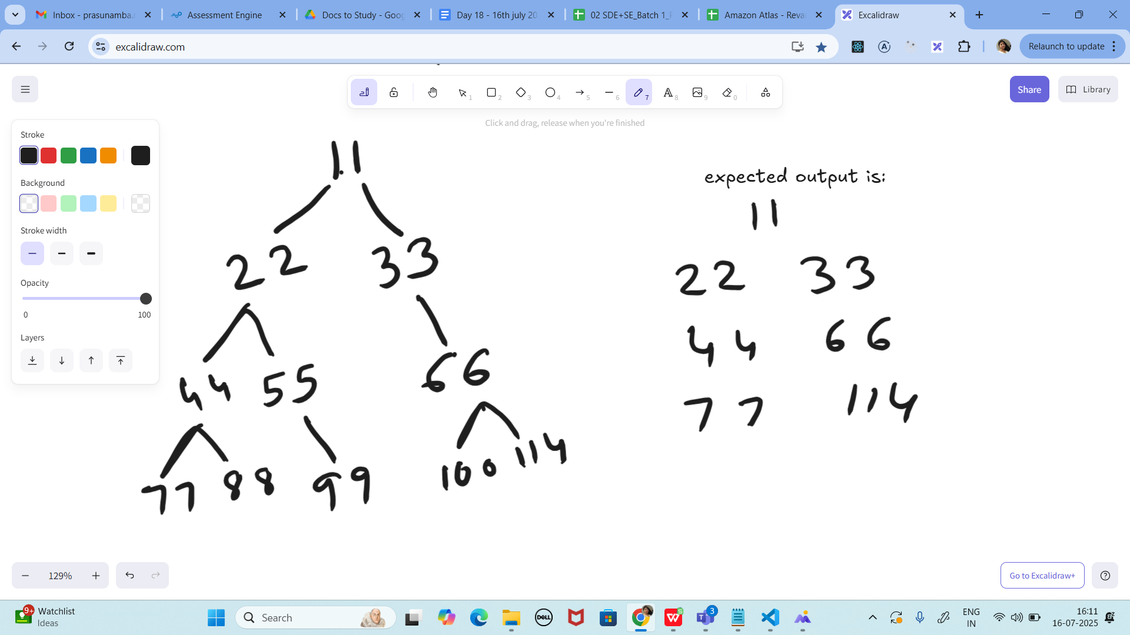
import java.util.*;

class Node {
int key;
Node left, right;

public Node(int key) {
this.key = key;
left = right = null;
}
}

public class Task17_BST {
Node root;

void printCorner(Node root) {
Queue<Node> q = new LinkedList<Node>();

q.add(root);
// level order traversal
while (!q.isEmpty()) {
int n = q.size();
for (int i = 0; i < n; i++) {
Node temp = q.poll(); // retrieve and remove the node

// Print the corner nodes (first or last node in the level)
if (i == 0 || i == n - 1)
System.out.print(temp.key + " ");

if (temp.left != null)
q.add(temp.left);
if (temp.right != null)
q.add(temp.right);
}
}
}

public static void main(String[] args) {
Task17_BST tree = new Task17_BST(); // Fixed class name
tree.root = new Node(11);
tree.root.left = new Node(22);
tree.root.right = new Node(33);
tree.root.left.left = new Node(44);
tree.root.left.right = new Node(55);
tree.root.right.left = new Node(66);
tree.root.right.right = new Node(77);

tree.printCorner(tree.root);
}
}

Task 18:

import java.util.*;

class Node {
int data;
Node left, right;

Node(int data) {
this.data = data;
this.left = this.right = null;
}
}

class ReverseAlternate{
static void storeAlternate(Node root, List<Integer> arr, int lvl) {
if (root == null) return;
storeAlternate(root.left, arr, lvl + 1);

if (lvl % 2 != 0)
arr.add(root.data);

storeAlternate(root.right, arr, lvl + 1);
}
static void modifyTree(Node root, List<Integer> arr, int lvl) {
if (root == null) return;
modifyTree(root.left, arr, lvl + 1);

if (lvl % 2 != 0) {
root.data = arr.remove(arr.size() - 1);
}
modifyTree(root.right, arr, lvl + 1);
}
static void reverseAlternate(Node root) {
List<Integer> arr = new ArrayList<>();
storeAlternate(root, arr, 0);
modifyTree(root, arr, 0);
}
static void printInorder(Node root) {
if (root == null) return;
printInorder(root.left);
System.out.print(root.data + " ");
printInorder(root.right);
}

public static void main(String[] args) {
Node root = new Node(1);
root.left = new Node(2);
root.right = new Node(3);
root.left.left = new Node(4);
root.left.right = new Node(5);
root.right.left = new Node(6);
root.right.right = new Node(7);

System.out.println("Inorder Traversal of given tree");
printInorder(root);

reverseAlternate(root);

System.out.println("\nInorder Traversal of modified tree");
printInorder(root);
}
}

Task 19:

Method 1 using BFS

class Solution {
public List<Integer> rightSideViewBFS(TreeNode root) {
if (root == null)
return new ArrayList<>();

List<Integer> ans = new ArrayList<>();
Queue<TreeNode> q = new ArrayDeque<>(List.of(root));

while (!q.isEmpty()) {
final int size = q.size();
for (int i = 0; i < size; ++i) {
TreeNode node = q.poll();
if (i == size - 1)
ans.add(node.val);
if (node.left != null)
q.offer(node.left);
if (node.right != null)
q.offer(node.right);
}
}

return ans;
}
}

Or
Method 2 using DFS

class Solution {
public List<Integer> rightSideViewDFS(TreeNode root) {
List<Integer> ans = new ArrayList<>();
dfs(root, 0, ans);
return ans;
}

private void dfs(TreeNode root, int depth, List<Integer> ans) {
if (root == null)
return;

if (depth == ans.size())
ans.add(root.val);
dfs(root.right, depth + 1, ans);
dfs(root.left, depth + 1, ans);
}
}

===============================================================================================================================================

Home Task – very very important

Pl explain

Task 17: display all corner elements of a tree

Task 18 Reverse Alternate levels

Task, 19 (leet code problem statement) right side view

